FACULTY EVALUATION
Programme Name: Social Entrepreneurship Program (SEP)- START Alumni MASTERCLASS (16th February 2026 - 20th February 2026)
Session: Long-term sustainability planning
Faculty Name: Felix Arthur Okoboi
No. of Respondents: 14
No. of Participants: 14
Evaluation Parameter | (%) Individual Score | (%) Programme Average
Punctuality (Commencement and Completion of Sessions) | 93 | 80
How well do you understand the core concepts presented? | 86 | 80
Rate your confidence in applying the new skills learnt | 83 | 74
Degree of Faculty preparedness for the sessions | 93 | 92
Content and methodology of the program | 91 | 87
Quality of class and group discussions | 86 | 74
The information presented in the course is relevant to my work (ministry) | 90 | 88
Average scores | 89 | 82

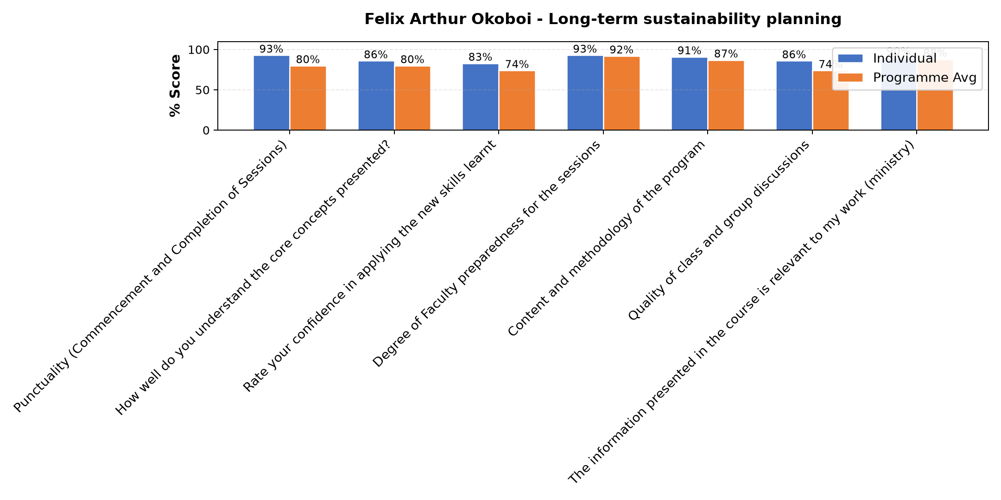

Comments & Feedback
- • Change of ministry ministry
- • In adquate funds
- • Transfers within a short time
- • Distance from the project site
- • the new ministry assigned.
- • Un planned transfer and not working within the field of an enterprise
- • Keeping records to me is a challenge and yet this is important
- • Fluctuation of prices
- • Limited capital
- • Abrupt Transfer to another community
- • My attendance was partial due to network problems. but i will apply the little i got.
SUBMITTED THROUGH:
SBS Evaluation Automation System

